Low Level Document (LLD)

Log analysis

. STUTI BHARDWAJ

**DECLARATION**

I declare that this written submission represents my ideas is our own words and where others' ideas or words have been included, I have adequately cited and referenced the original sources.

I also declare that i have adhered to all principles of academic honesty

and integrity and have not misrepresented or fabricated or falsified any idea/data/fact/source in my submission.

I understand that any violation of the above will be cause for disciplinary action by the Institute and can also evoke penal action from the sources which have thus not been properly cited or from whom proper permission has not been taken when

needed.

**Revision History**

**Cryptography**

**Digital signature**

**Viruses**

**worms**

**log analysis**

Table of Contents

1. Introduction ………………………………………………………………………………….6

1.1 Scope of the document…………………………………………………………………6

1.2 Intended Audience………………………………………………………………………6

1.3 System Overview………………………………………………………………………..7

1. Project Briefing……………………………………………………………………………….
2. Problem Statement…………………………………………………………………………..
3. Problem Solution……………………………………………………………………………..
4. Objective of Project…………………………………………………………………………..
5. Scope of Project………………………………………………………………………………
6. Block Diagram…………………………………………………………………………………
7. Requirements Gathering…………………………………………………………………….
8. Analysis……………………………………………………………………………………….

…………………………………………………

1. **Introduction:**

**1.1 Scope of the Document**

* This section will cover details regarding scope of the document
* Low level design document will be at component level i.e., for website portal there will be one LLD

**1.2 Intended Audience**

* This section will cover categories of audiences who will be referring/reviewing this document

**1.3 System Overview**

* This section will capture overview of system application i.e for what system is being developed
* Who are the stake holders of system?
* What are other external Systems through which this will be interacting

1. **Project Briefing:**

Logs provide health visibility and performance of the application stack and infrastructure, allowing teams of engineers and system administrators to easily identify and fix problems. Here is our basic five-step log management process for log analysis software:

Tool & Collection - install a collector to collect data from any part of your stack

Include and index - combine data from all log sources into one place to simplify the search and analysis process. Reference makes logs checked, so security and IT staff can quickly find the information they need

Search and Analyze - Analytical techniques such as pattern recognition, simplification, marking and correlation analysis can be applied by making or using a traditional reading machine.

Monitor and alert - With machine learning and statistics, IT organizations can use real-time, log-based monitoring that generates alerts when certain conditions are met. Automation can enable continuous monitoring of large volumes of logs that integrate a variety of programs and applications.

Report and dashboard - Simple reports and dashboard are important features of log analysis software. Customizable dashboards can also be used to ensure that access to private security logs and metrics is provided to employees on a need-to-know basis.

1. **Objective of the Project:**

Objective of this project is to create analysis behaviour.

1. **Scope of Project:**

It will be very helpful in our daily life because Data is the thing which can be seen in our life in every moment like if we travelling so on toll tax we can see so many vehicles are going and coming at that time logs are useful. just like logs are useful and that analysis would be make better results.

1. **Block Diagram:**

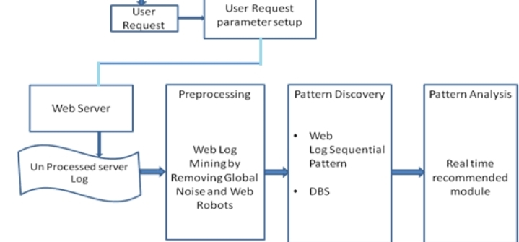

1. **Requirements Gathering:**

* Window 10 Operating system
* Google collab
* Pycharm
* Ideas of different different person
* Graphical tool

1. **Analysis:**

Log analysis is the process of reviewing, translating and understanding computer-generated records called logs. Logs are produced by a range of structured technologies, including network devices, operating systems, applications, and more. A log contains a series of contextual messages describing the ongoing activities within the system. Log files may be distributed to the log collector via an active network, or they may be stored in files for later updating. In any case, log analysis is a soft art of reviewing and translating these messages to gain insight into the internal functioning of the system.

Question analysis is one of the areas of research to analyze log focused focus. Research has shown that short queries and the lack of improved search usage equate to digital library search. One search term was used in 81.5% of search operations, and only 18.49% search by Boolean operators, with a minimum of 0.1% of Boolean search results including previous results (Sfakakis and Kapidakis, 2002). According to Lowe's (2013) analytical search log for the ARTstor Cultural Heritage Digital Library, the average number of words per query is 1.88 words. About 80% of the questions consist of two words or less, and half of the questions are one-term questions (49.70%) and 30.07% as two-term questions. Unique questions, rare questions, and quizzes by refiners make up 54.89%, 21.39%, and 23.73%, respectively. Remarkably, the questions become more general, simpler, and shorter. The findings are confirmed by another study analysis of digital library logs that report an average of 1.96 terms per question (Han et al., 2014). In search of myths, searchers averaged 1.4 words per question when conducting simple searches, but most questions (75%) contain only one term. In Advanced Search, the queries are made up of 1.95 words per question. The most notable findings are that 3.4 result pages are viewed on average (Trieschnigg et al., 2013).